ULPS – Setting up Telehealth Accounts

**How to set up your Telehealth Capabilities:**

**Setting up your Vidyo Account:**

1. This can be done from any computer (does not have to be MLH), phone, or iPad
2. Type <https://associates.telehealth.methodisthealth.org> into your web browser.
3. Install **VidyoConnect** to your computer by hitting “Run”. Once you download it, it becomes an icon on your desktop.
   1. **Portal: associates.telehealth.methodisthealth.org**
   2. **Username: Computer/Cerner log on**
   3. **Password: Cerner password**
4. The first time you log in, click “Meetings” on the taskbar on left and sync to your Outlook calendar. **You must have the Outlook application open on your desktop to send invitations.**
5. The first time you log in, search for your division’s rooms and add to your favorites by clicking the star to the right. All ULPS rooms start with “ULPS_”
   1. 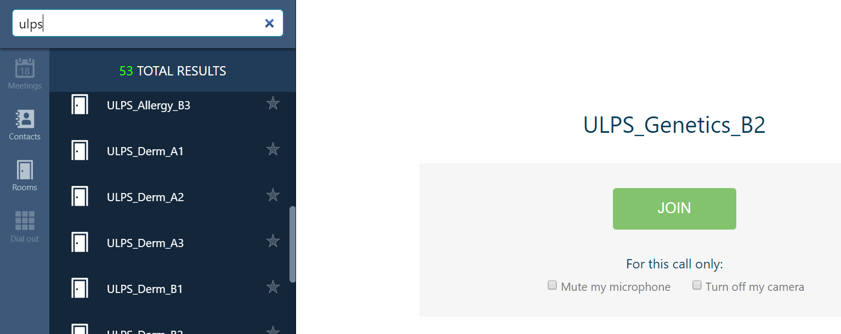

**Find the links to your Vidyo rooms**

1. Each specialty has between 2-8 rooms, depending on how many physicians are expected to do telehealth.
2. For each of your rooms, you’ll need to obtain the link so you can use it to send to patients. Click on your division room and “ Join it”
   1. 
3. Expand your screen
4. Click the 3 lines on the top left of the screen and switch to Moderator 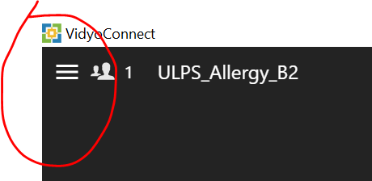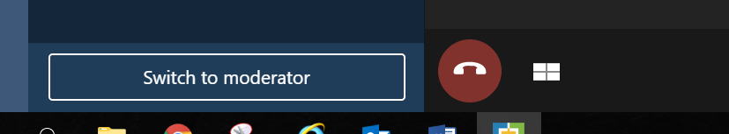
5. Enter a PIN of 1234
6. Click Moderate Call and Open in Browser option will appear on the right 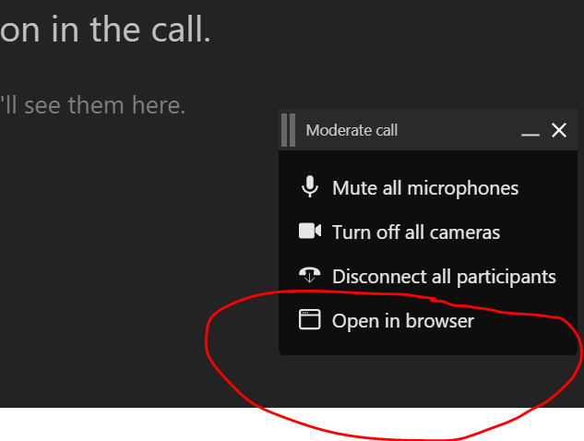
7. Enter 1234 in the browser PIN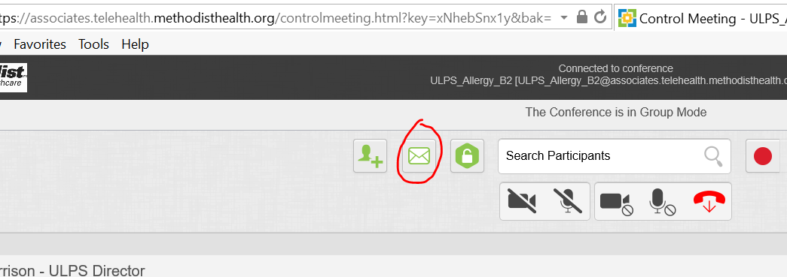
8. Click on the email icon. The below email will generate that includes the room link you will need to save to a document for future use. Each room has a unique link.

